Please find below attached Portswigger Screenshots for solved problems as well as Dashboard progress.

1. Portswigger Dashboard Track Progress.png

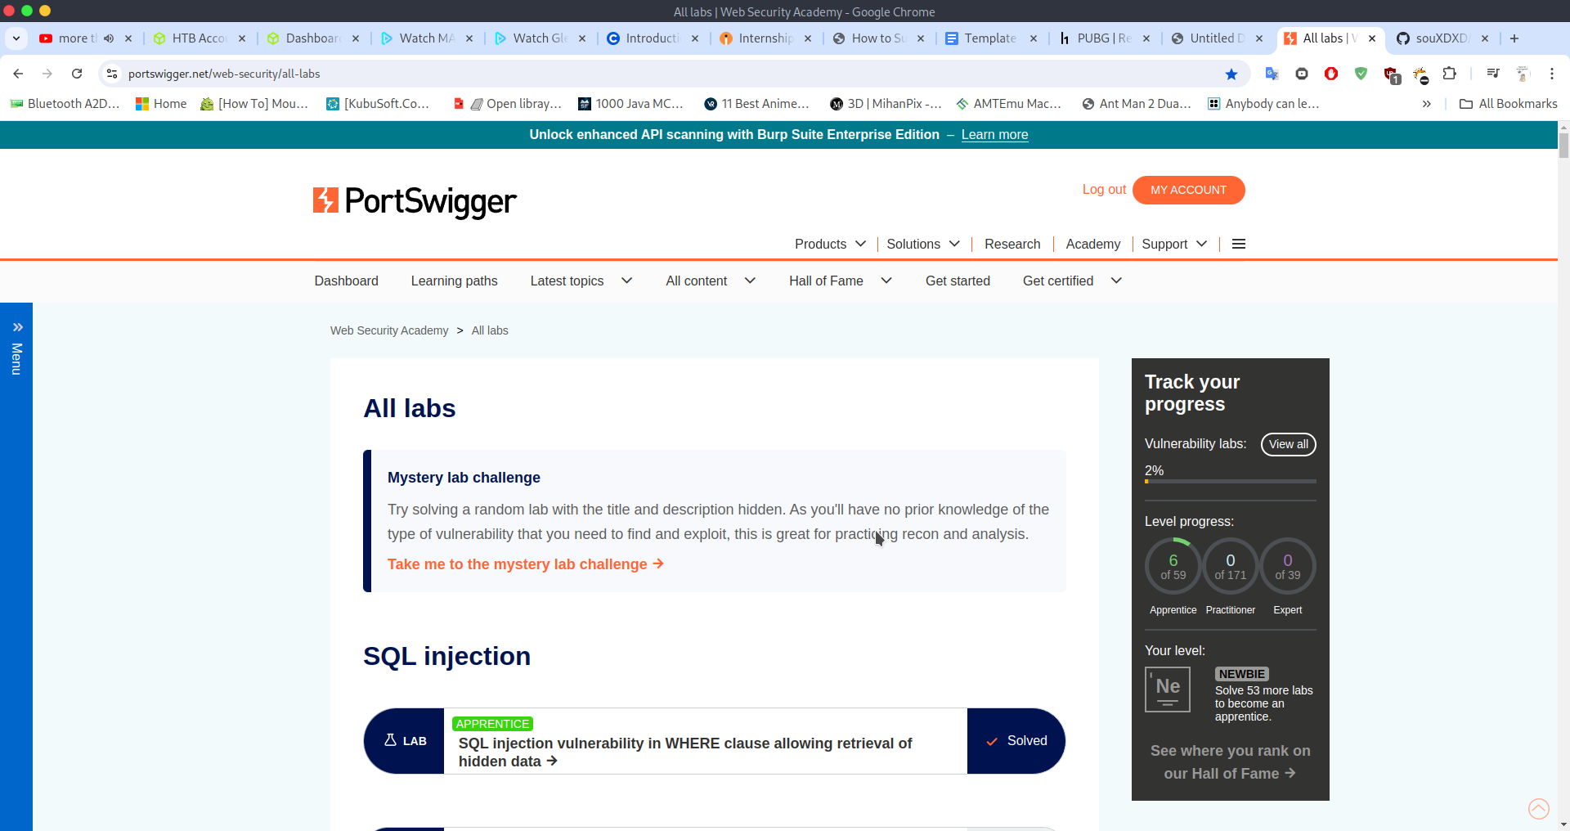

2. OS command injection Portswigger.png

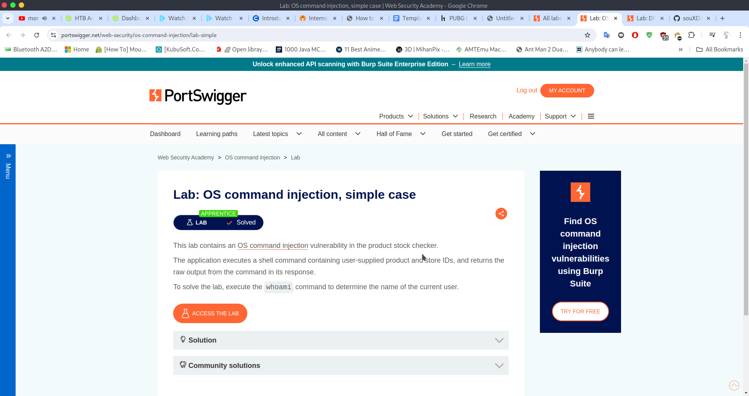

3. Portswigger DOM XSS in document.write sink using source location.search.png

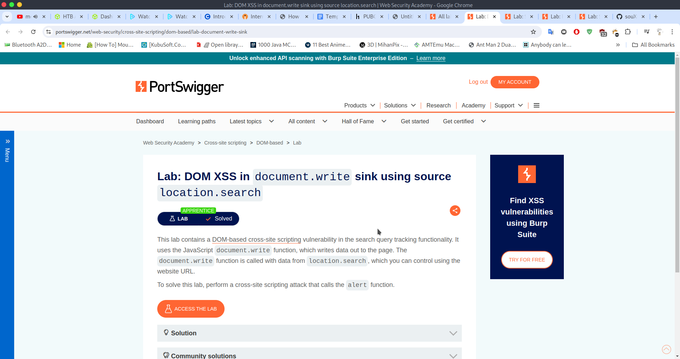

4. Portswigger DOM XSS in innerHTML sink using source location.search.png

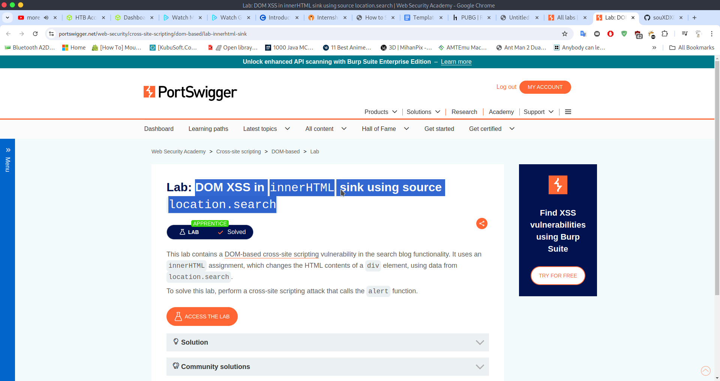

5. Portswigger Reflected XSS into HTML context with nothing encoded.png

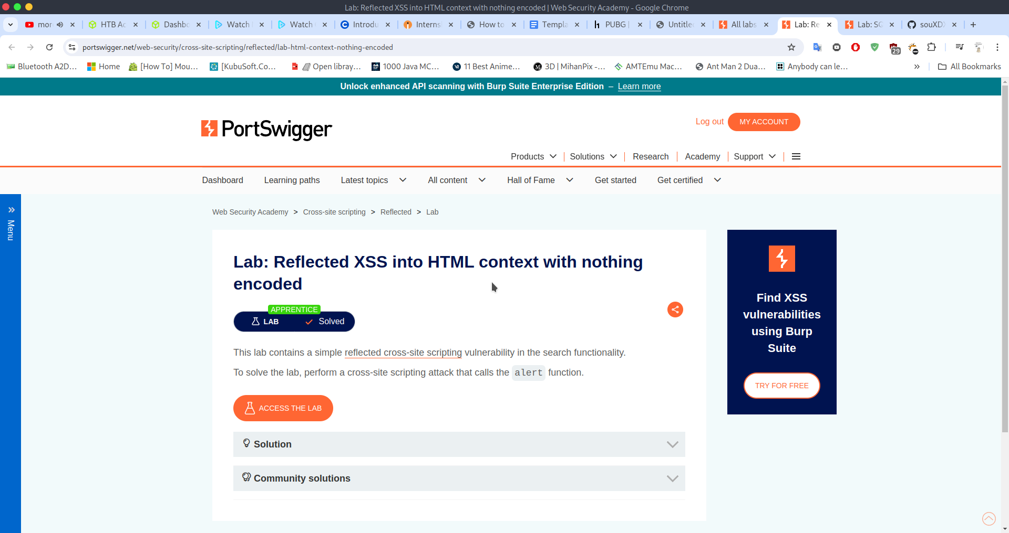

6. Portswigger SQL injection vulnerability in WHERE clause allowing retrieval of hidden data.png

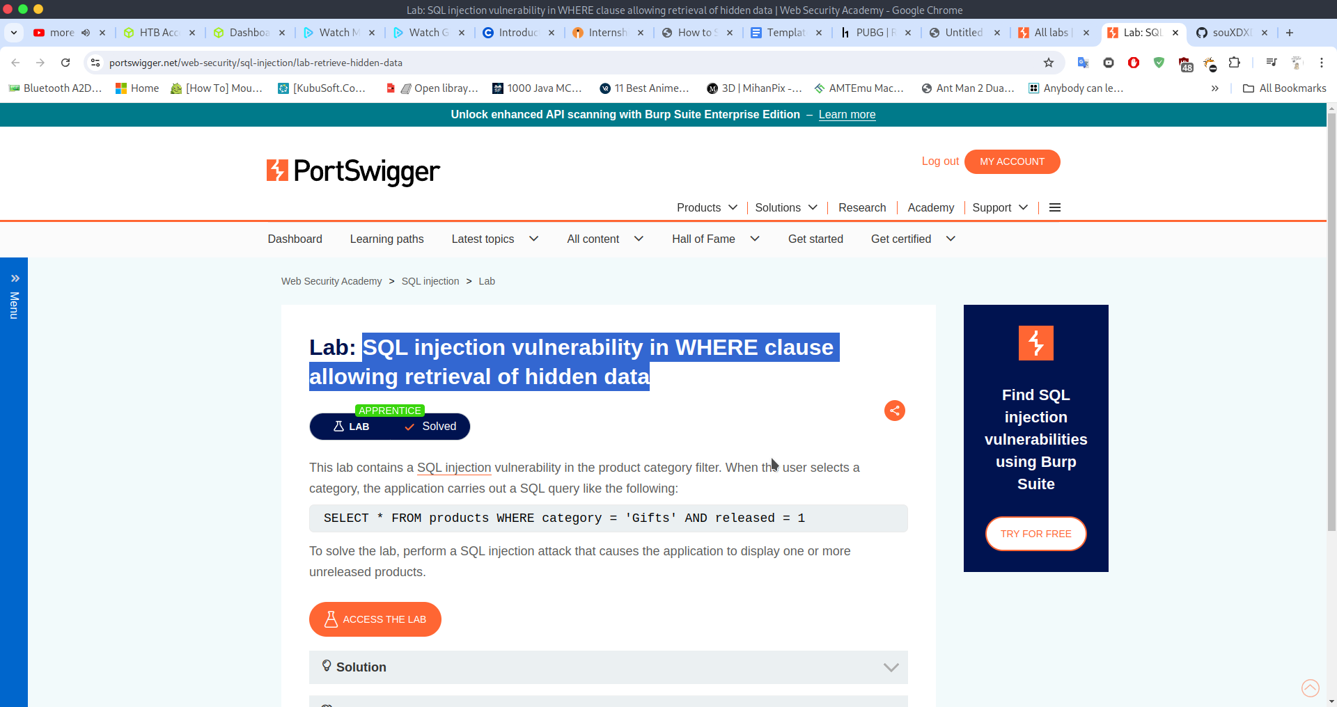

7. Portswigger Stored XSS into HTML context with nothing encoded.png

